**Network Definition and Vocabulary:**

**Definitions:**

**Network –** A representation of connections among a set of items.

**Nodes –** where these items are called nodes.

**Edges –** the connection relationship between these nodes.

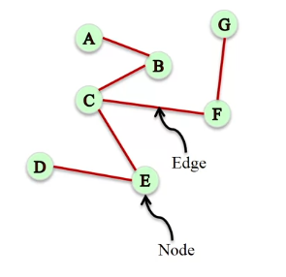

**E.g.** The following network shows the relationship between 2200 people with the edges being the connection between them and the nodes being the people. We can see that most of the relationships between nodes is **symmetric**, meaning that if A is a friend of B then B is a friend of A.

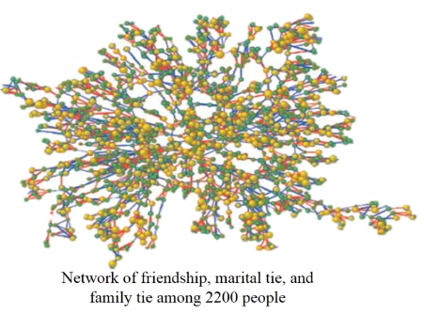

Direction in network analysis is very important, the following example shows the relationships between predator and pray. This is an **asymmetric relationship**.

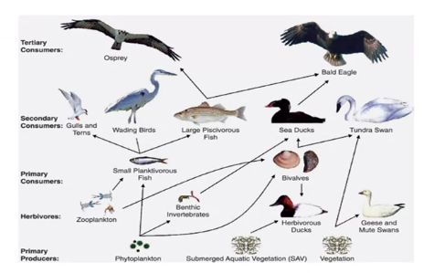

This suggests that we need two different types of networks, some need to show direction (**Directed Networks**­) and other do not (**Undirected Networks**). For **undirected networks** we would use the class Graph() seen in the notebook. For **directed networks** we would use the class DiGraph(). Note that for **directional networks** the order in which the edges are added matter, e.g. B -> A != A -> B.

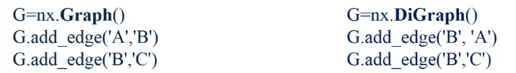

**Weighted Networks**:

Not all edges have equal weighting, for example in an email connection network the number of emails sent per week might strengthen the connection and add more weight to the edge.

In general, these edges are assigned weights which are usually numerical values. E.g. the network of who had lunch together. We can see that the connection between C and E is much stronger than the connection between D and E. We have to define the connection using a weighting that can be added in the add_edge() method.

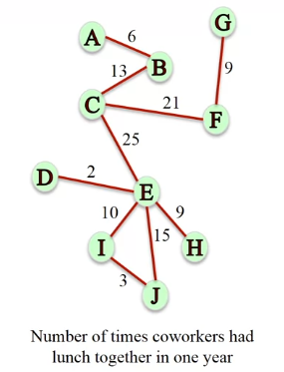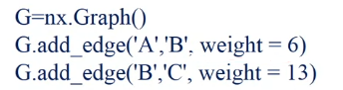

**Signed Networks**:

Some networks can carry information about the type of relationship between people, e.g. if they are friends or foes. The edges instead of having a weight now have a positive or negative sign attached to them.

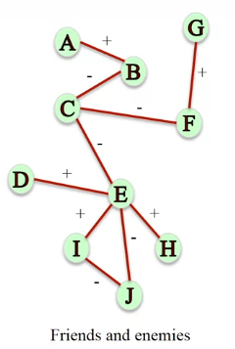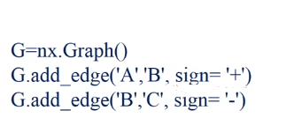

**Other Edges:**

There are many different types of edges that can be used, for example the connection between people would be linked between their relationships to one another (friend, co-worker, neighbour, partner, etc).

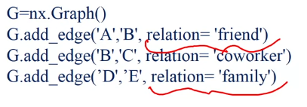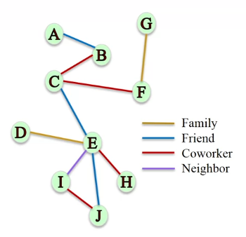

**Multigraphs:**

These are used to capture multiple different types of relationships between two nodes, someone could be friends and also co-workers. More generally this is a network where multiple edges can connect to the same node.

